



ML Ops & Containerization
LAB MANUAL

Disclaimer: The content is curated from online/offline resources and used for educational purpose only
Loan Approval Prediction API Testing and Validation
Objective
To test and validate a Loan Approval Prediction REST API using Swagger UI and Postman to ensure accurate request processing and prediction responses.
Problem Statement
A financial institution has developed a machine learning REST API that predicts whether a loan application will be approved based on applicant information. Test the API using Swagger UI and Postman by sending different applicant details, validating API responses, checking error handling, and confirming that the prediction service functions correctly.
Requirements
- Python 3.x
- FastAPI
- Uvicorn
- Loan Approval Prediction API
- Swagger UI
- Postman
- Web Browser
- Internet Connection
Procedure
Project Structure
loan-approval-api/
│
├── app.py
├── train_model.py
├── loan_approval.xlsx
├── loan_model.joblib (created after training)
└── requirements.txt

Step 1: Install Required Libraries
pip install fastapi uvicorn pandas numpy scikit-learn joblib

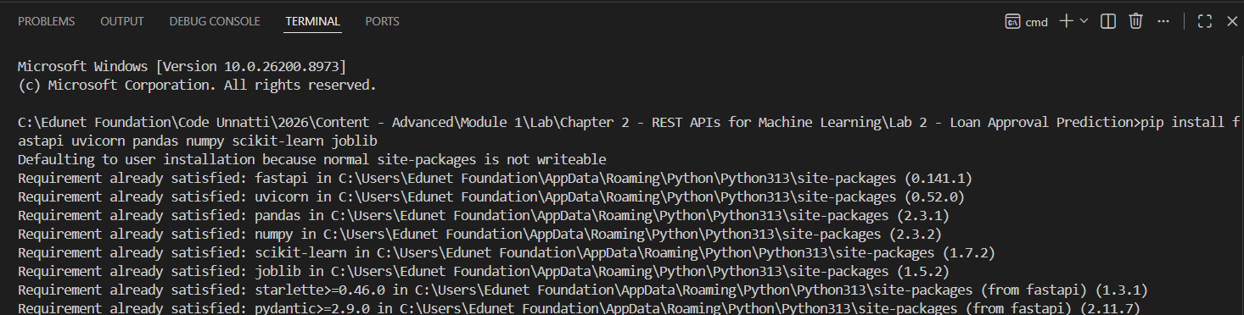
Create requirements.txt:
fastapi
uvicorn
pandas
numpy
scikit-learn
joblib

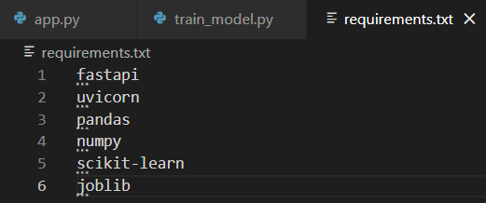
Step 2: Review the Dataset
loan_approval.xlsx contains 500 applicant records across 13 columns: 12 feature columns and one target column, Loan_Status, with values "Y" (approved) or "N" (not approved).

Step 3: Train the Machine Learning Model
Create train_model.py:
import pandas as pd
from sklearn.model_selection import train_test_split
from sklearn.compose import ColumnTransformer
from sklearn.pipeline import Pipeline
from sklearn.preprocessing import OneHotEncoder
from sklearn.ensemble import RandomForestClassifier
import joblib

# 1. Load the dataset
data = pd.read_excel("loan_approval.xlsx")

# 2. Separate features (X) and target (y)
# Use every column except the target, instead of a small hand-picked subset, so the model can use all available signals.
X = data.drop(columns=["Loan_Status"])

# The target is text ("Y"/"N"); map it to 1/0 for the classifier and so the API's output is unambiguous.
y = data["Loan_Status"].map({"Y": 1, "N": 0})

# 3. Identify categorical vs. numerical columns
categorical_cols = X.select_dtypes(include=["object", "string"]).columns.tolist()
numerical_cols = X.select_dtypes(exclude=["object", "string"]).columns.tolist()

# 4. Preprocessing: one-hot encode categorical columns
# Gender, Married, Education, Self_Employed and Property_Area are text columns. Passing them straight into RandomForestClassifier, as the original script did, raises "could not convert string to float". handle_unknown="ignore" also protects the live API from crashing on a category value that was not seen during training.
preprocessor = ColumnTransformer(transformers=[
("num", "passthrough", numerical_cols),
("cat", OneHotEncoder(handle_unknown="ignore"), categorical_cols),
])

# 5. Combine preprocessing and model into a single pipeline
# This guarantees app.py reuses the exact same encoding at prediction time, rather than re-implementing it separately.
model = Pipeline(steps=[
("preprocessor", preprocessor),
("classifier", RandomForestClassifier(n_estimators=200, random_state=42)),
])

# 6. Split into training and test sets, then train
X_train, X_test, y_train, y_test = train_test_split(
X, y, test_size=0.2, random_state=42, stratify=y
)
model.fit(X_train, y_train)

# 7. Evaluate and save
accuracy = model.score(X_test, y_test)
print(f"Model Trained Successfully. Test Accuracy: {accuracy:.2f}")
joblib.dump(model, "loan_model.joblib")
print("Model Saved Successfully")

Run the script:
python train_model.py

Step 4: Create the FastAPI Application (app.py)
Create app.py:
from fastapi import FastAPI
from pydantic import BaseModel
import pandas as pd
import joblib

app = FastAPI(title="Loan Approval Prediction API")

# Load the trained pipeline once at startup, not per request.
model = joblib.load("loan_model.joblib")

@app.get("/")
def home():
"""Simple health-check endpoint."""
return {"message": "Loan Approval Prediction API Running"}

# Request schema: every feature the model was trained on.
# Using Pydantic here means FastAPI validates types and reports clear errors automatically.
class LoanApplication(BaseModel):
Age: int
Gender: str
Married: str
Dependents: int
Education: str
Self_Employed: str
ApplicantIncome: int
CoapplicantIncome: int
LoanAmount: int
Loan_Amount_Term: int
Credit_History: int
Property_Area: str

@app.post("/predict")
def predict(application: LoanApplication):
# Convert the validated request body into a single-row DataFrame. Column names must match those seen in training, since the saved pipeline selects columns by name.
row = pd.DataFrame([application.dict()])

# The pipeline re-applies the same one-hot encoding used during training, so text fields can be passed in as-is.
prediction = model.predict(row)[0]
probability = model.predict_proba(row)[0][1]

result = "Loan Approved" if prediction == 1 else "Loan Rejected"
return {
"Prediction": result,
"approval_probability": round(float(probability), 2),
}
Step 5: Start the FastAPI Application
uvicorn app:app --reload

Expected output:
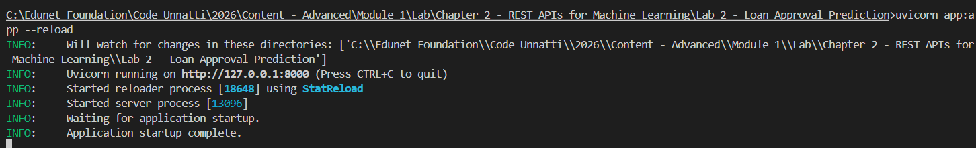
Step 6: Open Swagger UI Documentation
Open your browser and navigate to:
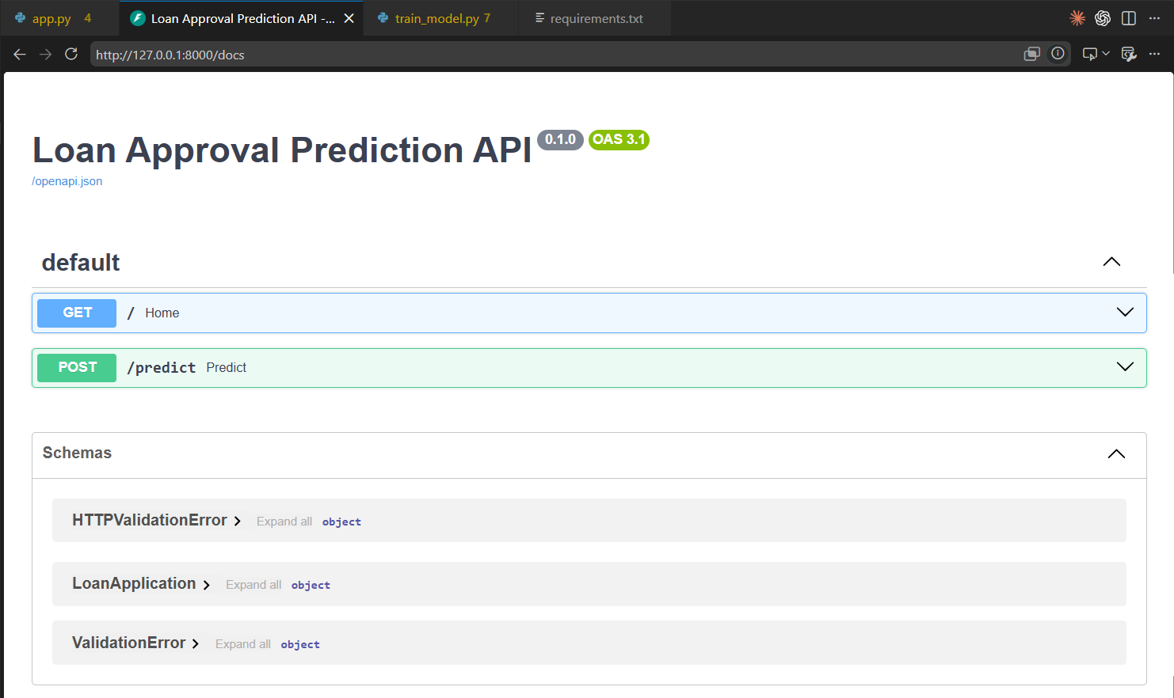

Step 7: Execute a Prediction Request Using Sample Applicant Data
In Swagger UI, click POST /predict, then Try it out, and replace the sample request body with:
{
"Age": 26,
"Gender": "Female",
"Married": "Yes",
"Dependents": 1,
"Education": "Graduate",
"Self_Employed": "No",
"ApplicantIncome": 37122,
"CoapplicantIncome": 51724,
"LoanAmount": 458992,
"Loan_Amount_Term": 180,
"Credit_History": 1,
"Property_Area": "Urban"
}

Click Execute.
Step 8: Verify the Returned JSON Response
Output:
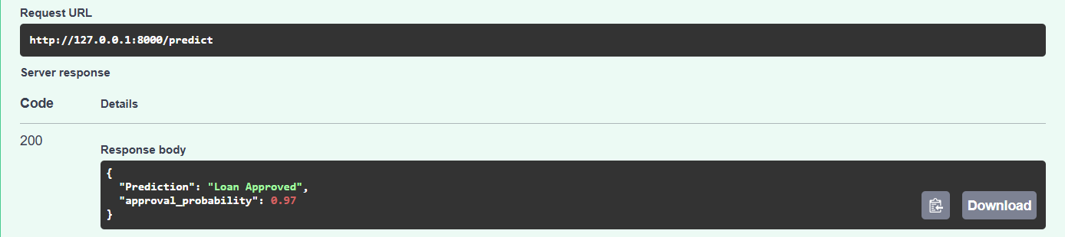

Another example, using an applicant with no credit history on file:
{
"Age": 39,
"Gender": "Male",
"Married": "Yes",
"Dependents": 0,
"Education": "Graduate",
"Self_Employed": "No",
"ApplicantIncome": 38456,
"CoapplicantIncome": 46505,
"LoanAmount": 246818,
"Loan_Amount_Term": 180,
"Credit_History": 0,
"Property_Area": "Urban"
}

Expercted Output:
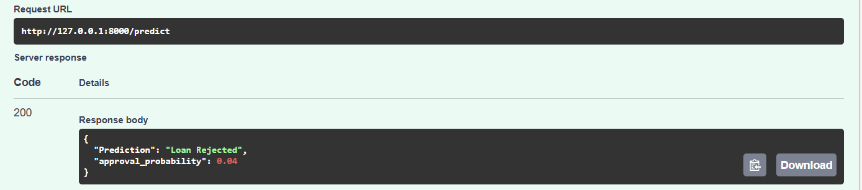
Conclusion
In this lab, a Loan Approval Prediction REST API was built with FastAPI and then systematically tested using Swagger UI and Postman. The model - a RandomForestClassifier wrapped in a scikit-learn Pipeline that one-hot encodes categorical applicant fields such as Gender, Married, Education, Self_Employed, and Property_Area alongside the numeric fields - was trained on all 12 real feature columns in loan_approval.xlsx rather than a small, partly non-existent subset.

